Assignment 4 – Finite Automata and Context-free grammar

Exercise 1

1. (0?)(10?)\* 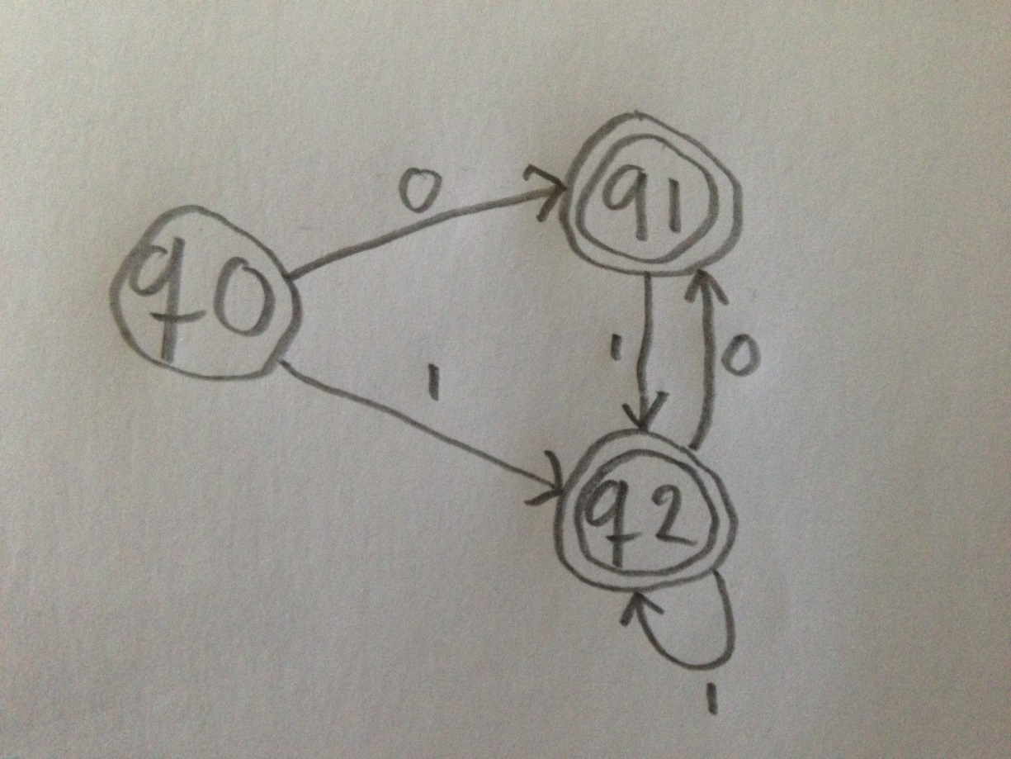
2. (0|1)(0|1)(0|1)+ 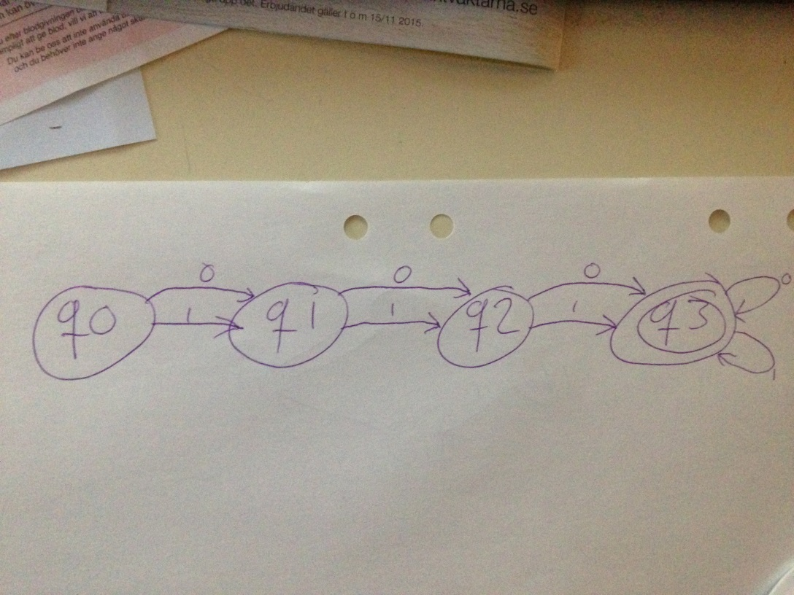
3. (1\*(01)\*)\* 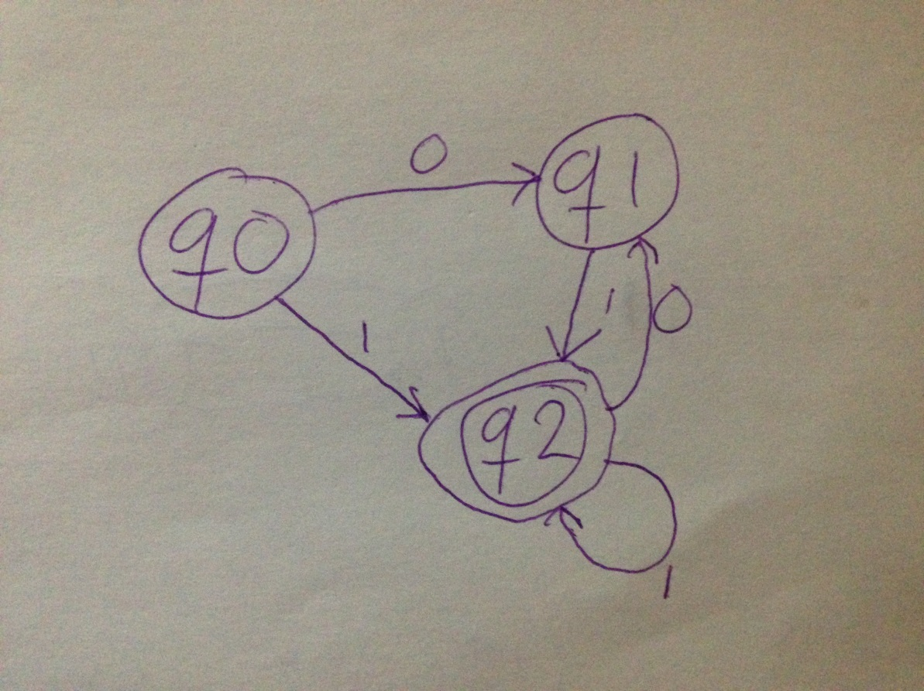
4. (00(((0|1)\*00)\*|0\*)\*)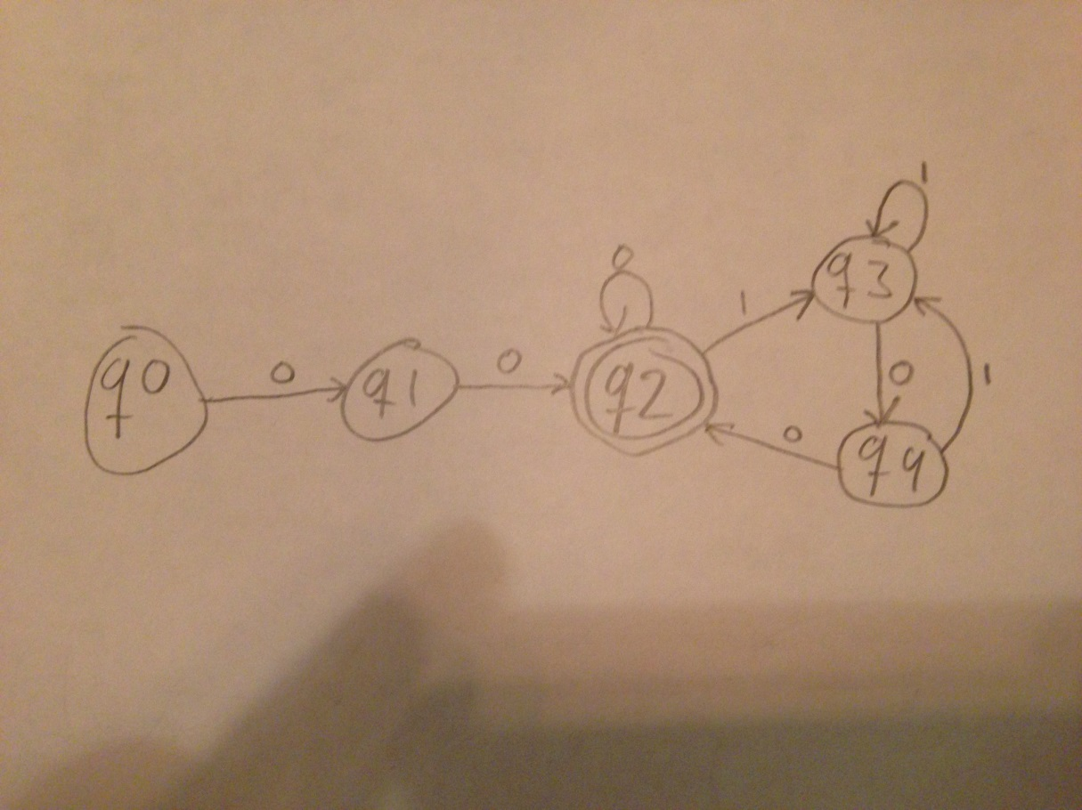
5. ((00|11)\*(01|10)(11|00)\*(10|01)(00|11)\*|(11|00))\*(01|10)(00|11)\* 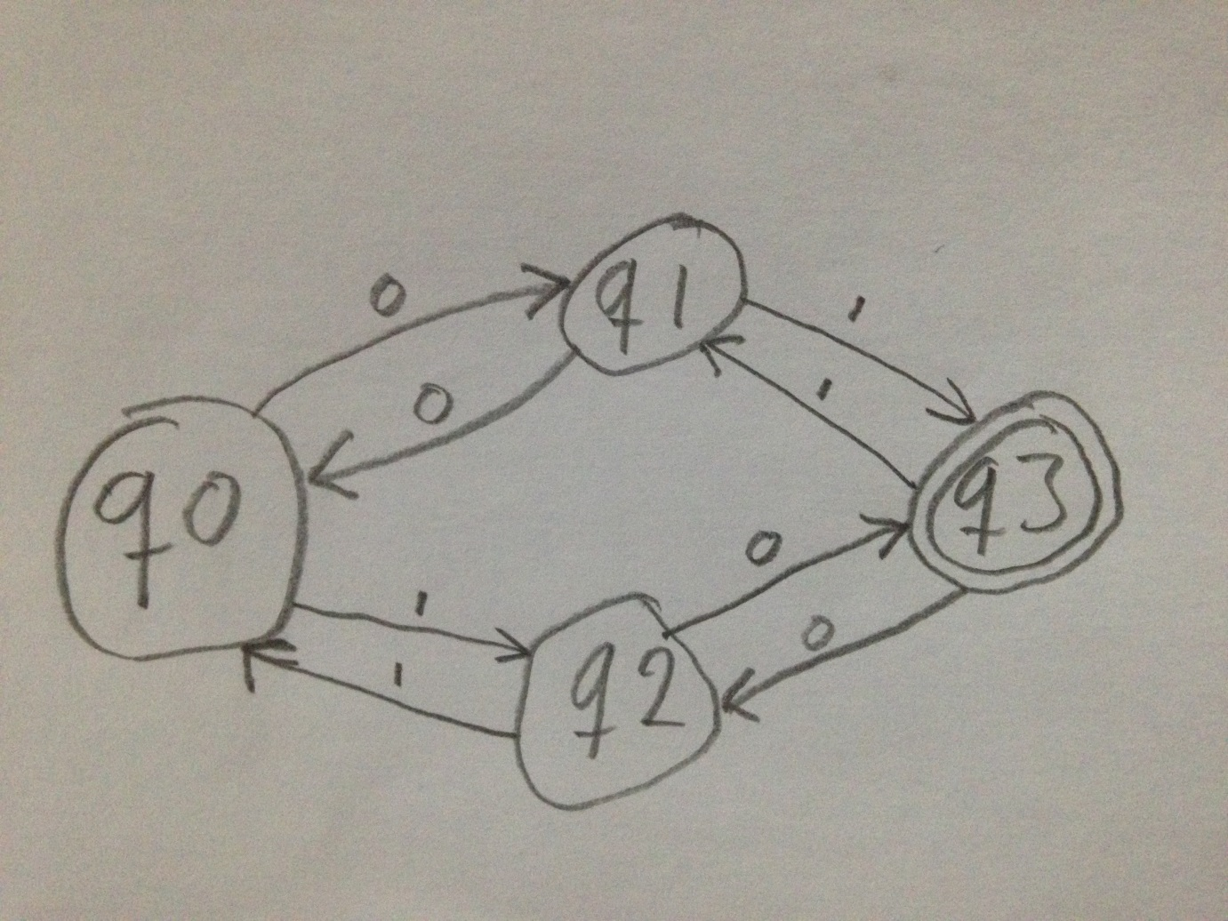

Exercise 2

(0((12)|(34\*5)))\* 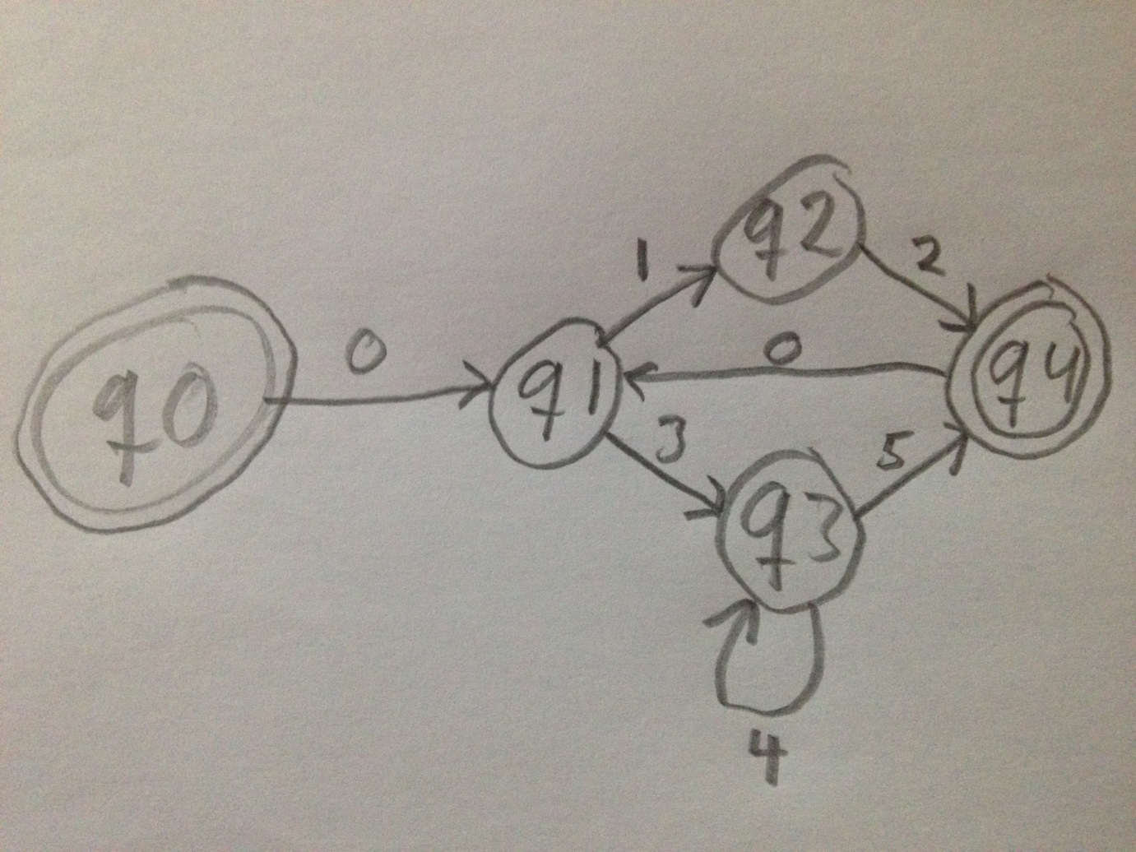

Exercise 3

1. A -> 00 | A1A | A0 | 0A
2. A -> B0B, B-> 1 | ε
3. A -> CBBBC, B -> 0 | 1, C -> B | CC | ε
4. A -> 0A11 | 011 | ε
5. A -> 0 | 1 | B, B -> 1A1 | 0A0

Exercise 4

1. a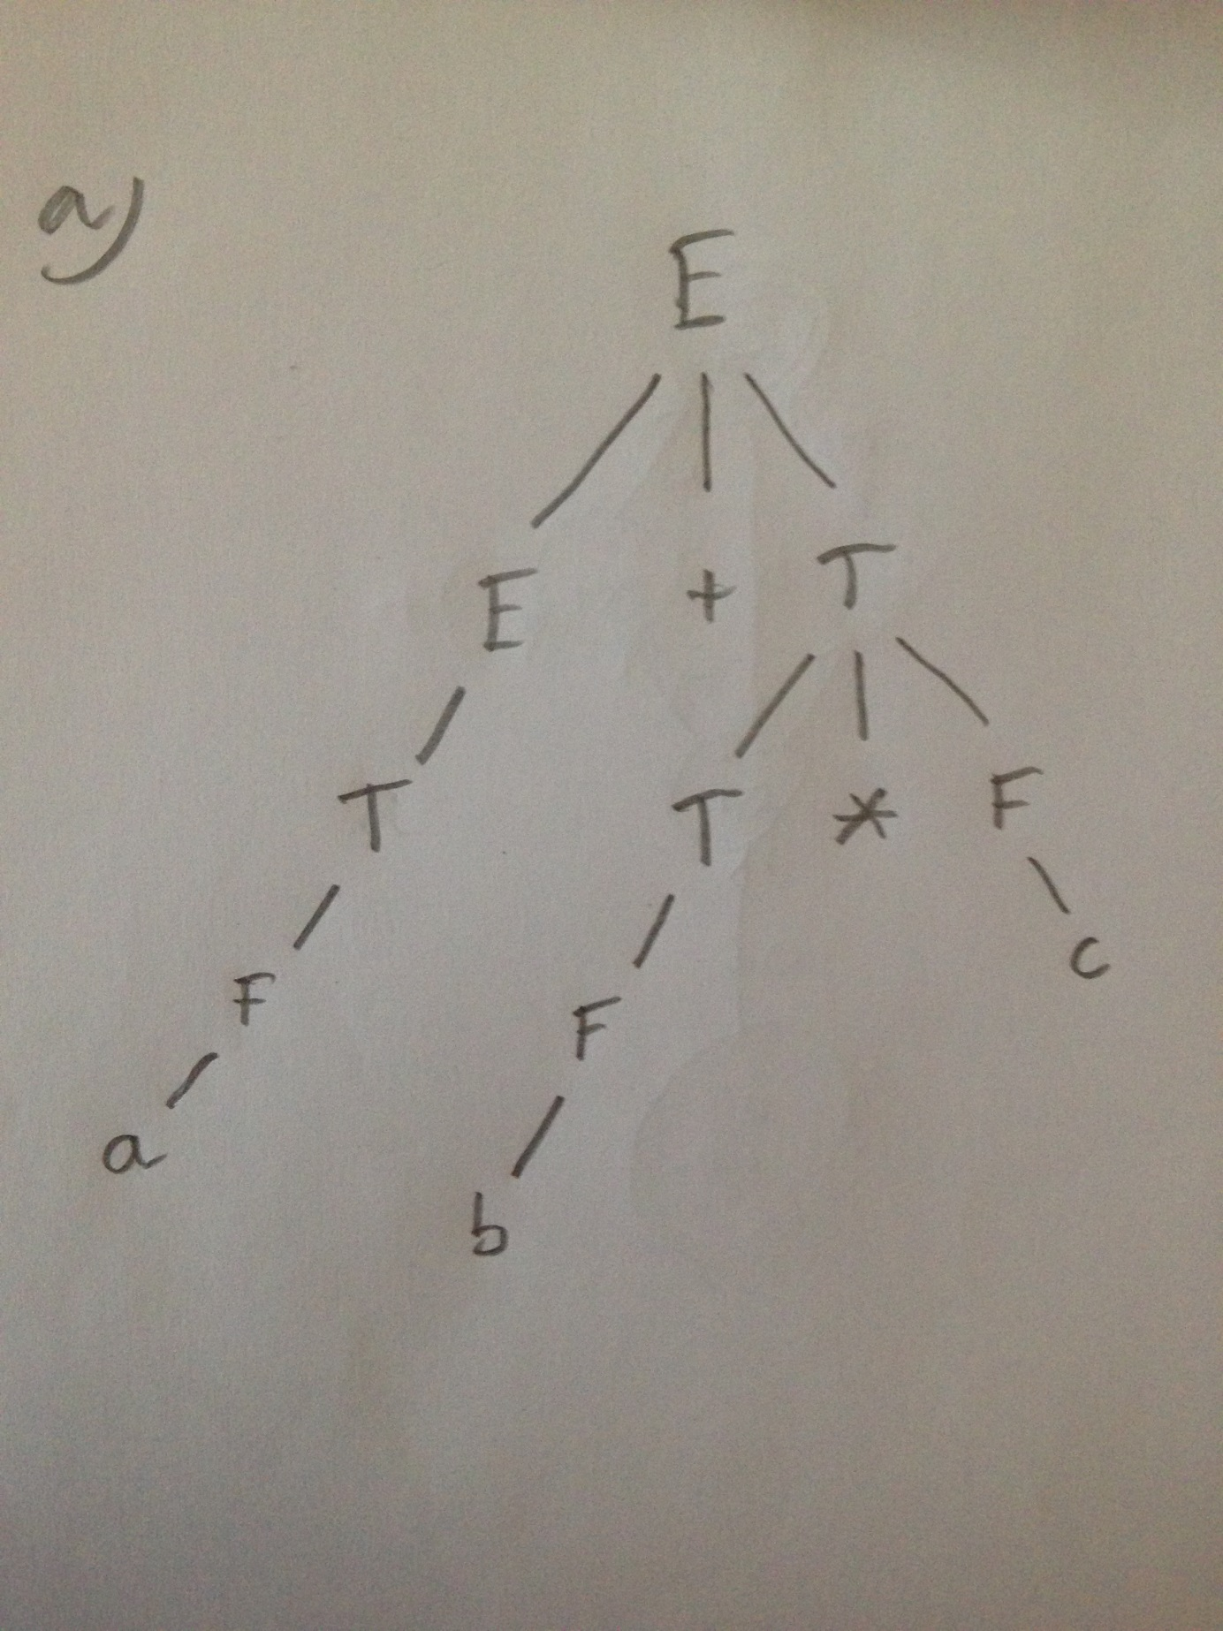
2. b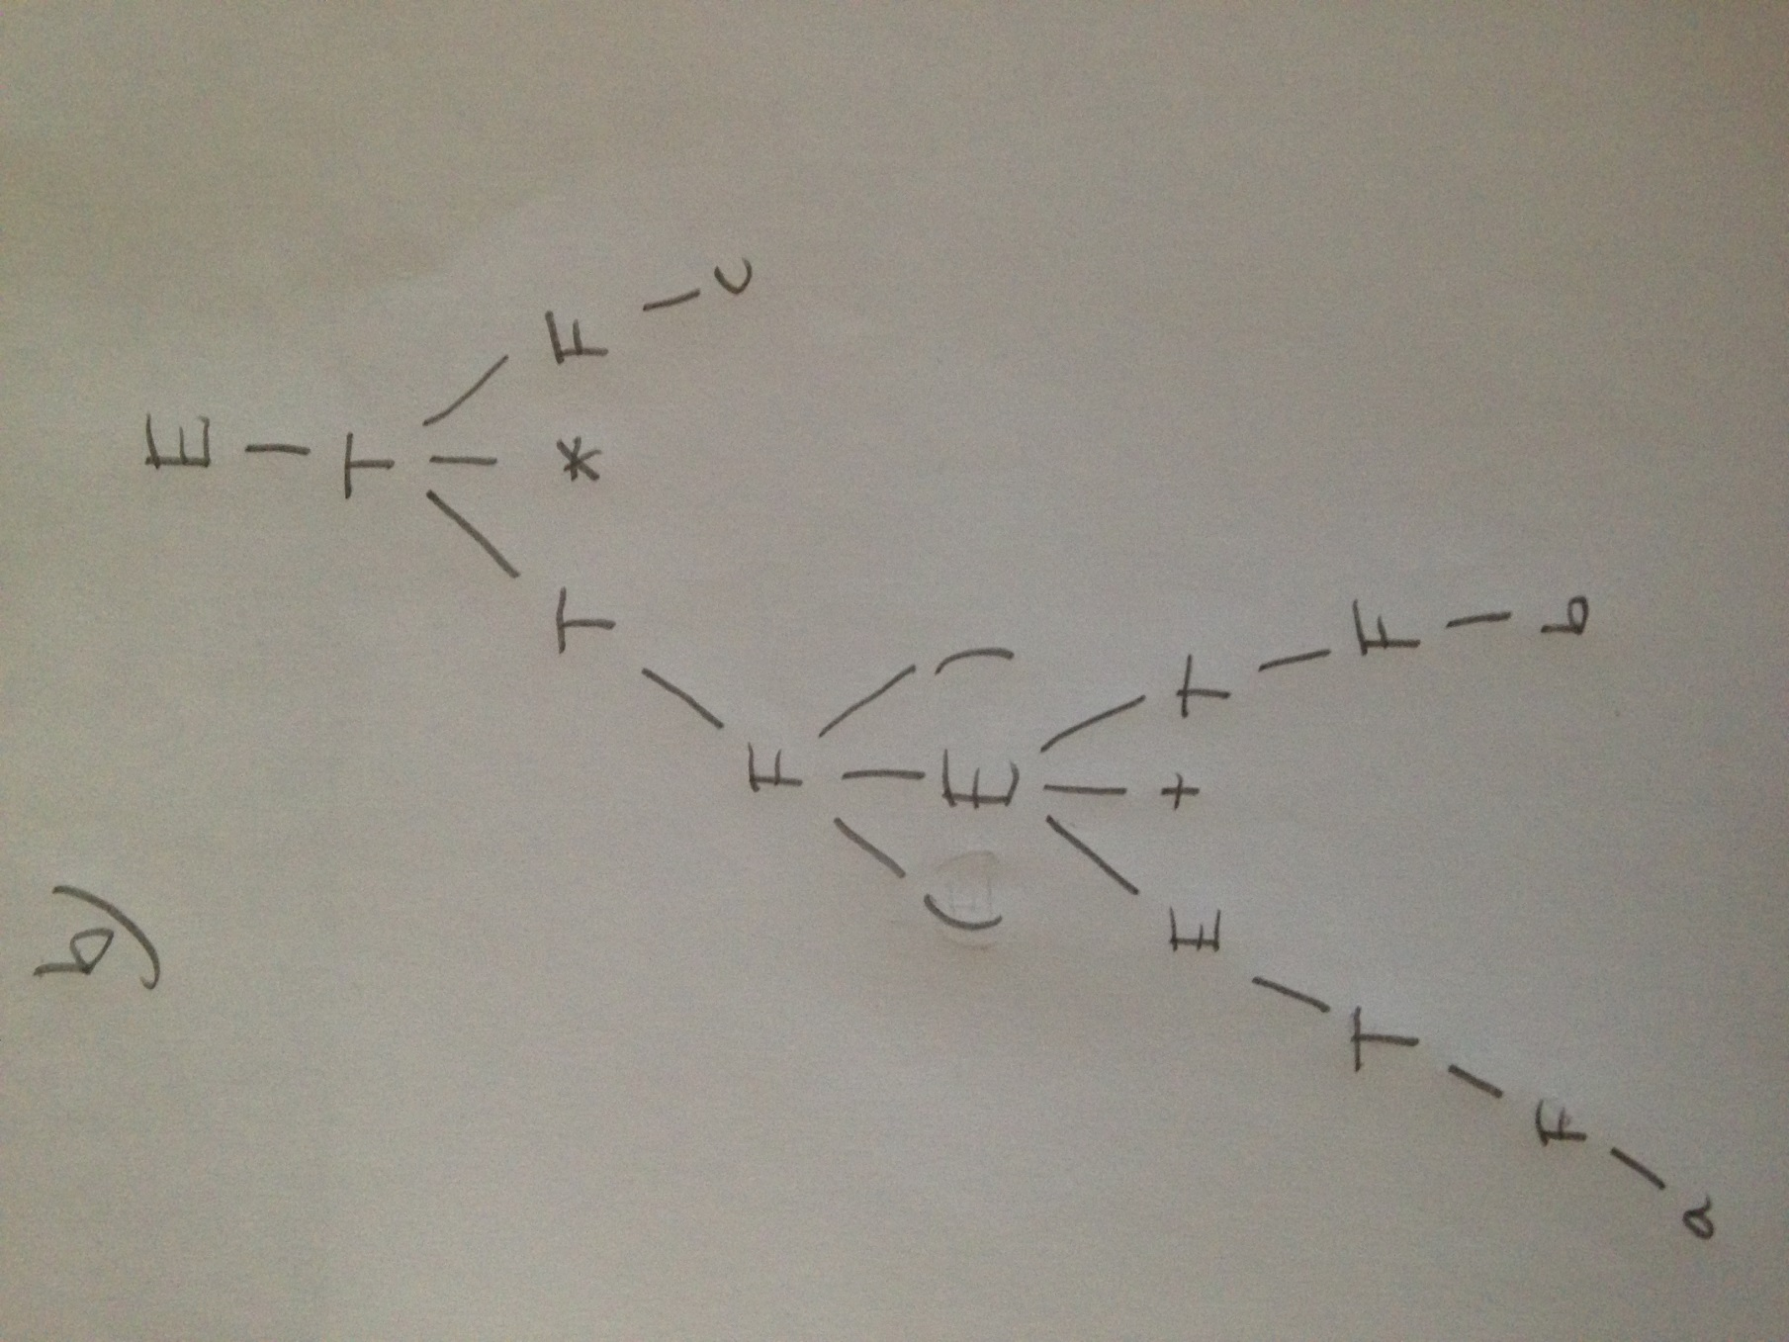
3. c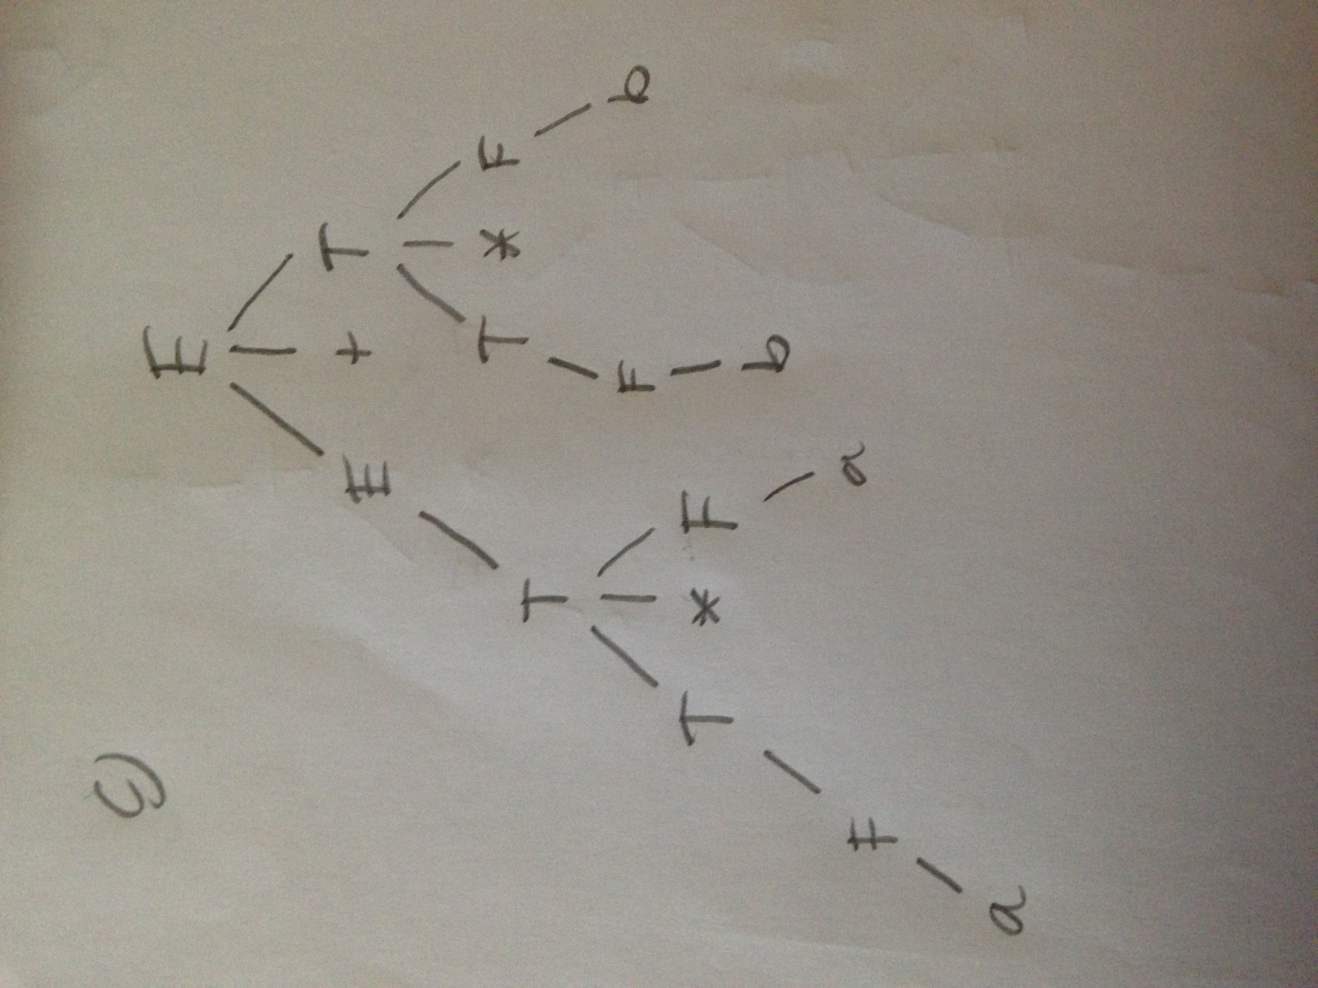

Exercise 5

For the string “bab”, two parse trees are possible: